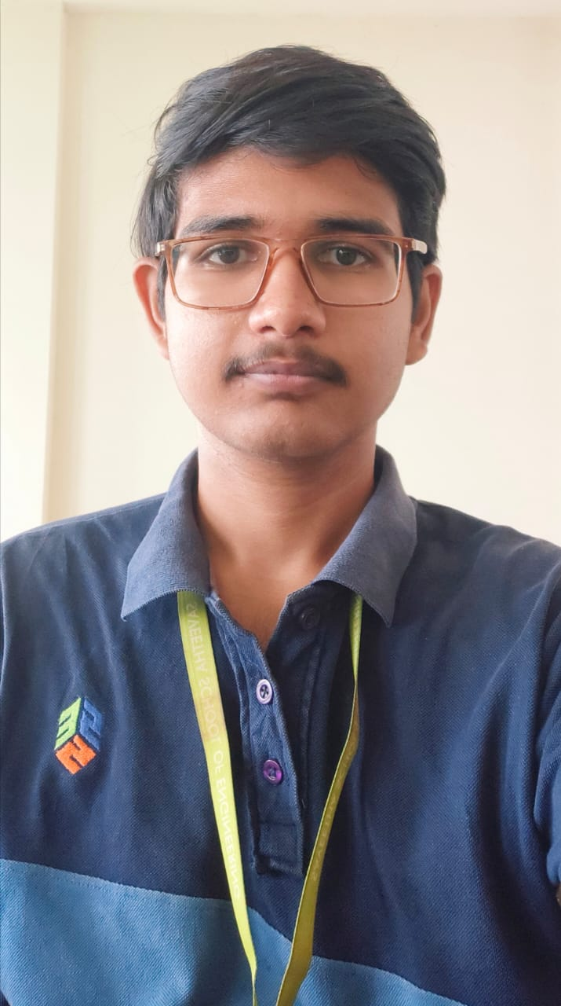
Namburi Sai Balaji
AI&ML 3rd Year

Mobile No: +91 9010749497

Gmail : saibalajiomg@gmail.com

Github:-https://github.com/SaiBalaji-N

LinkedIn : https://www.linkedin.com/in/sai-balaji-namburi-2ba521235/

PROFESSIONAL SUMMARY

- Enthusiastic student who can easily get adapted to any situation.
- Eager to improve my skills where ever there is an opportunity.
- Passionate and Self Motivated

EXPERIENCE SUMMARY:

- Have done a 1 month internship in “Python” on Skill Vertex.

- Currently Pursuing Python Bootcamp On Data Analytics

ACADEMIC DETAILS

- Bachelor of Technology in Artifitial Intelligence and Machine Learning from Saveetha University (Year 2021-2025)-8.5(CGPA) currently pursuing.
- Higher Secondary Education from Sri Chaitanya JR.Kalasala (Year 2019-2021) 93.4%.
- Secondary School Education from Sri Vidya High School(Year 2018- 2019)  9.8(GPA).

PERSONAL DETAILS

Languages known : English, Telugu, Hindi.
Hobbies : Reading Books, Playing Badminton, Cooking Food.
Date of birth : 17/02/2004
Address : 3-177-402,Raithupeta Down,LP Side Bazar 3,Nandigama,Krishna District,521185,
Andhra Pradesh

TECHNICAL SKILLS

Python (numpy,pandas,matplotlib,seaborn)
Machine Learning (sklearn)
Deep Learning(Tensorflow)
Natural Language Processing (Spacy,Nltk)
SQL Basics
PowerBI

